Ideation Phase
Empathize & Discover

Date | 31 January 3035
Team ID | SWTID-2026-3968
Project Name | AI FAQ Assistant
Maximum Marks | 4 Marks

Empathy Map Canvas:
An empathy map is a simple, easy-to-digest visual that captures knowledge about a user’s behaviours and attitudes.

It is a useful tool to helps teams better understand their users.
Creating an effective solution requires understanding the true problem and the person who is experiencing it. The exercise of creating the map helps participants consider things from the user’s perspective along with his or her goals and challenges.
Example:
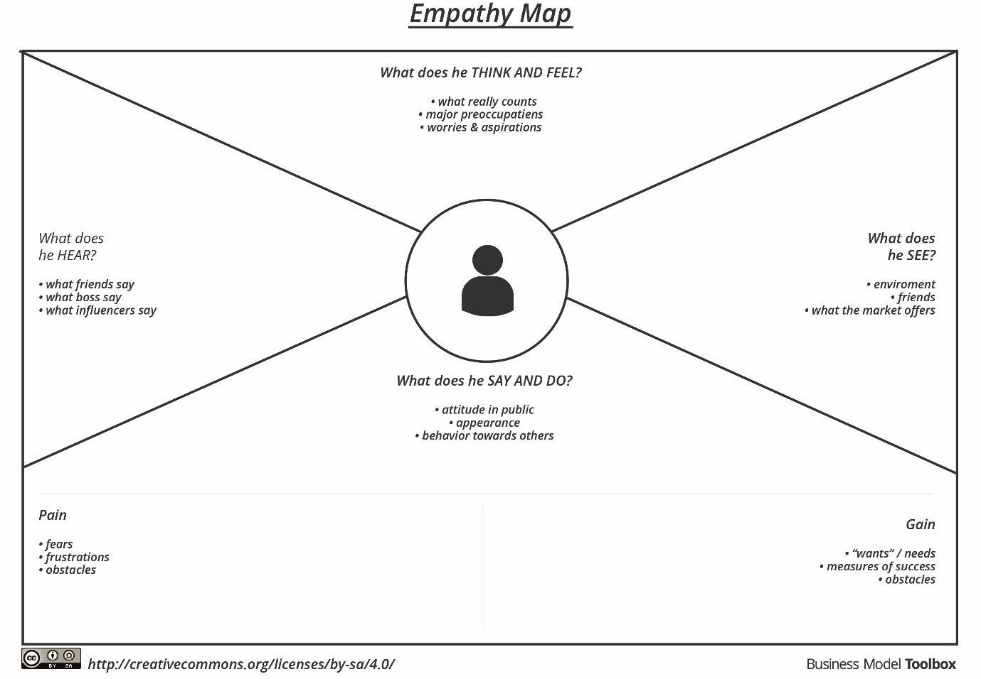

Reference: https://www.mural.co/templates/empathy-map-canvas

Example: Food Ordering & Delivery Application
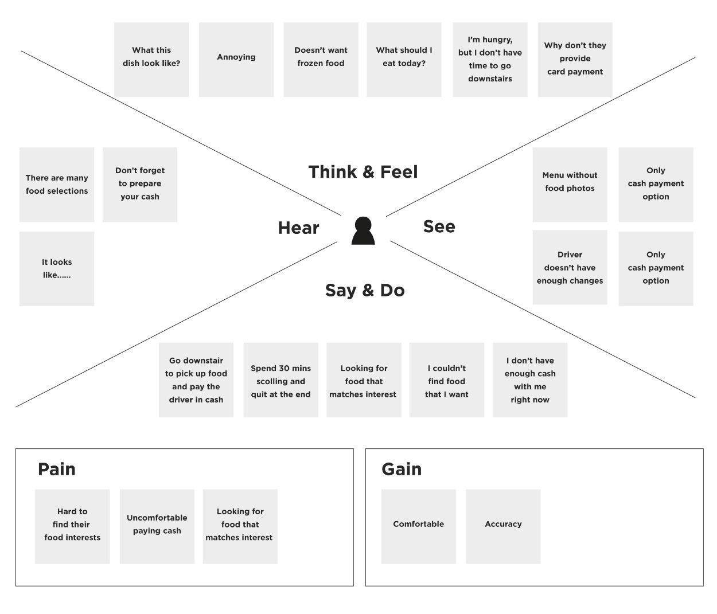
Empathy Map – Primary User: Learner / Knowledge Seeker
Says | Thinks | Does | Feels
“I need a direct answer.” / “Can I search this quickly?” | “Is the information reliable?” / “Can AI explain it simply?” | Searches FAQs, enters questions, reads answers, uses AI assistance. | Curious, time-conscious, frustrated by repetitive searching.
User Pains & Gains
Pains | Gains
Scattered information; repetitive FAQ creation; uncertainty about answer quality; time spent searching. | Fast answers; searchable FAQ repository; AI-generated FAQ content; secure user access.

